Question 15: List down possible tasks for a user story:

* Using Program evaluation and review technique (PERT) to fill in the missing Duration in number of days as below:

|  |  |  |
| --- | --- | --- |
|  | Library System |  |
| Activity | Duration(days) | Predecesors |
| A | 2 | - |
| B | 3 | - |
| C | 2 | A |
| D | 4 | A,B |
| E | 5 | C |
| F | 3 | C |
| G | 6 | D,E |
| H | 8 | F,G |

* Draw Network Diagram of these tasks.

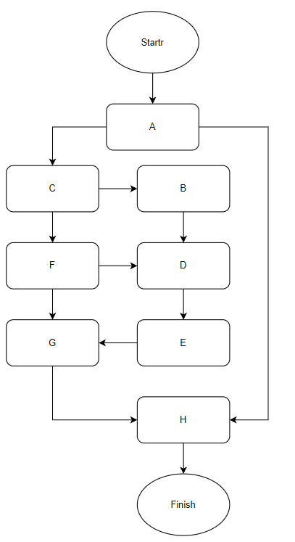

* Find Critical Path using Critical Path Method.

Critical Path: [a,c,f,b,d,e,g,h]